Report Assignment 4

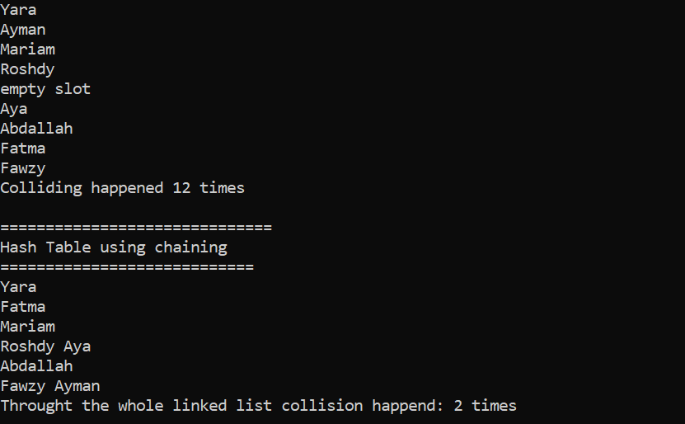

The first one uses linear probing however the second print uses chaining.

In my opinion, linear probing is better than chaining because:

1. It uses less memory space than chaining. This is due to the reason that each index in chaining will use a linked list which thus makes it use a much bigger space than linear probing.
2. In accessing the data in linear probing assures you that it will take an O(1) – constant complexity. However with chaining the worst case scenario will be O(N) where N represents the length of the longest linked list in the indexes of the hash tables
3. Another benefit that we have from the previous reason, is that it is easier to access. And this is due to the reason that that the data is not as scattered as in the chaining. But rather it is consecutively close together since it is stored in a linear data base.

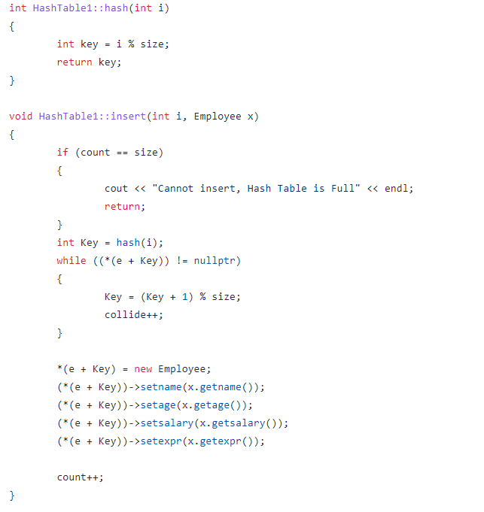Linear probing:

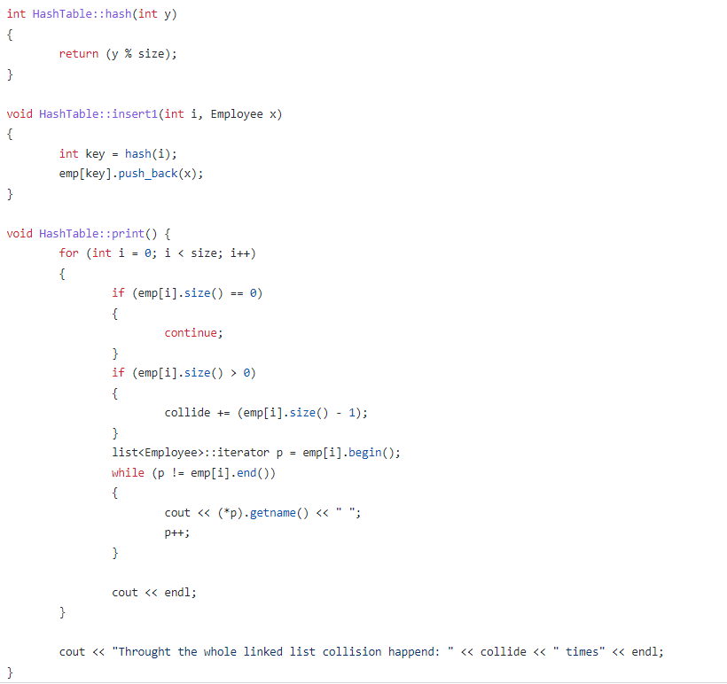

Chaining: